Complete the summary below of the sustainable tourism scheme in Ethiopia. Use key terms and examples from the newspaper extract.
Where is the sustainable tourism scheme? | Describe the natural (physical) attractions of the area that attract tourists? | Describe the human-made features of the landscape that attract tourists (including culture).
What are the economic lives of the locals like without tourism? | 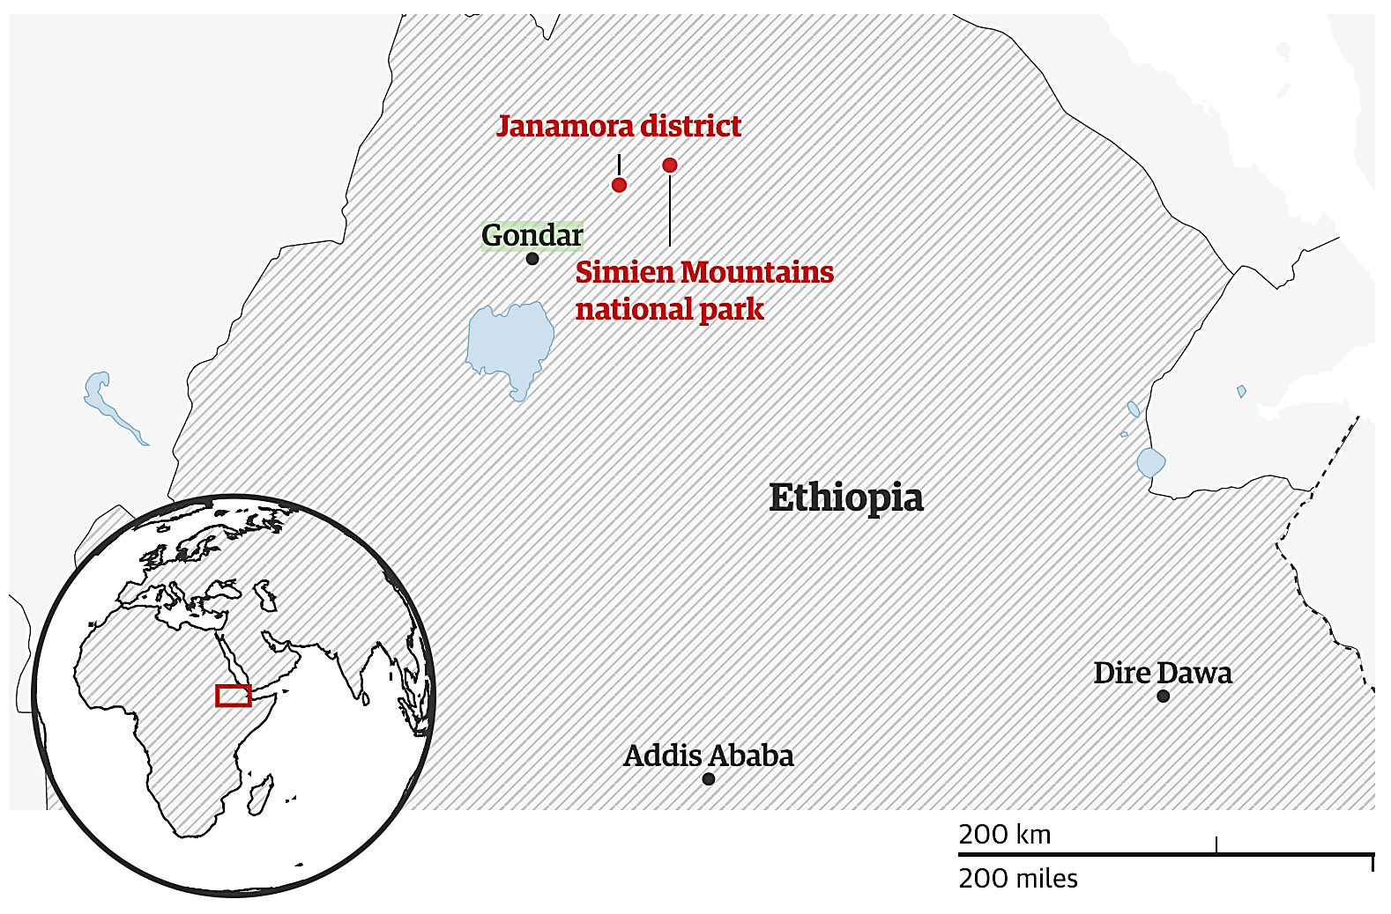 | How does tourism improve the economic lives of the locals?
What impact do the locals seem to have on the environment? | Do tourists damage the environment when they visit? | Why is tourism in Janamora sustainable?

